Add a starter page with the following information:

**Data Science Level 1 Certification Test**

**Part 1: 9 questions, 10 minutes**

Part 1 comprises stand-alone multiple choice and fill in the blank questions that are randomly selected from a question bank.

**Part 2: 15 questions, 110 minutes**

Part 2 requires test takers to:

1. Download one or more datasets.
2. Create a code notebook – Python or R – using their own computer environment, for use in answering questions about the dataset(s).
3. Upload their completed code notebook through the testing platform (after all questions are completed, test takers will be directed to a new page for uploading).

**Grading**

To pass, test takers must:

1. Anwer at least 85% of all questions correctly on Parts I and II; and
2. Submit their completed code notebook used for answering Part II questions. The notebook will be reviewed by the certification team and must clearly show the test taker’s process for answering all Part II questions.

**Retaking the Test**

After the first try, test takers may repeat the test once per month (including the month the first attempt was made).

Wording:

**Data Science Level 1 Certification Test**

**Part 1: 9 questions**

**Duration: 10 minutes**

Part 1 comprises stand-alone multiple choice and fill in the blank questions that are randomly selected from a question bank.

Formatting:

* Align title with the rest of the text
* Title color should be same as teal color used in Data Lab logo

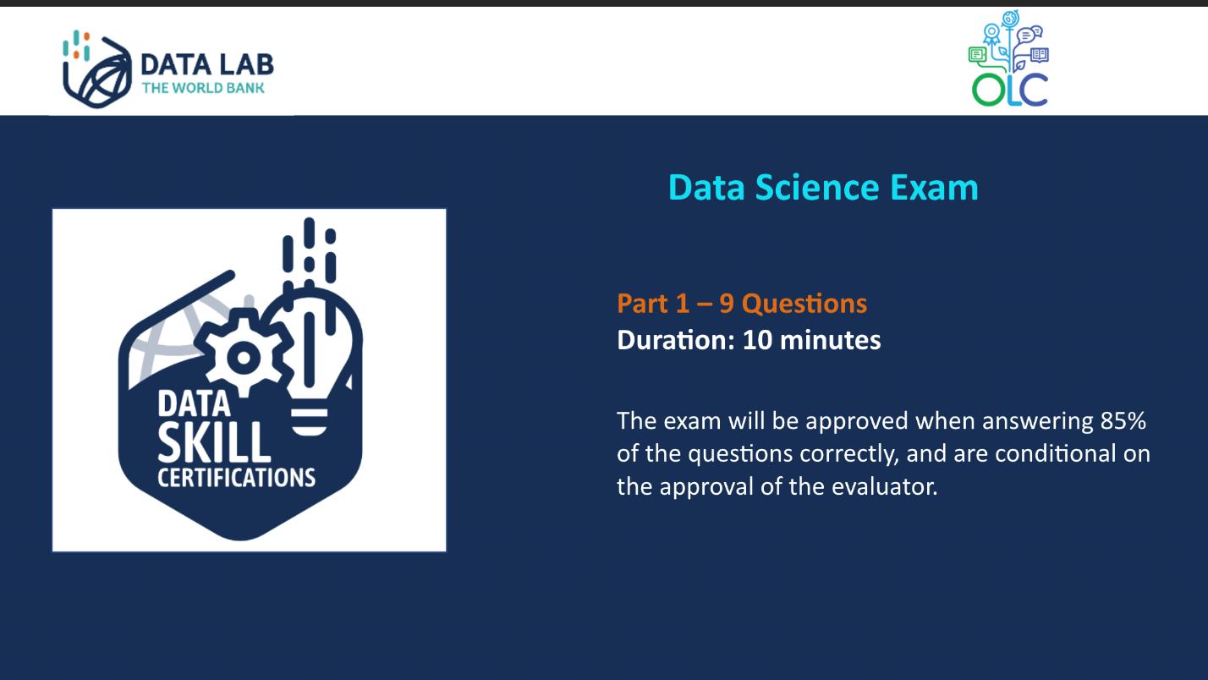

A~~dd a dot after Q1 (.) for the final - I understand the E and letter will not show on the final test.~~



Missing 3rd answer

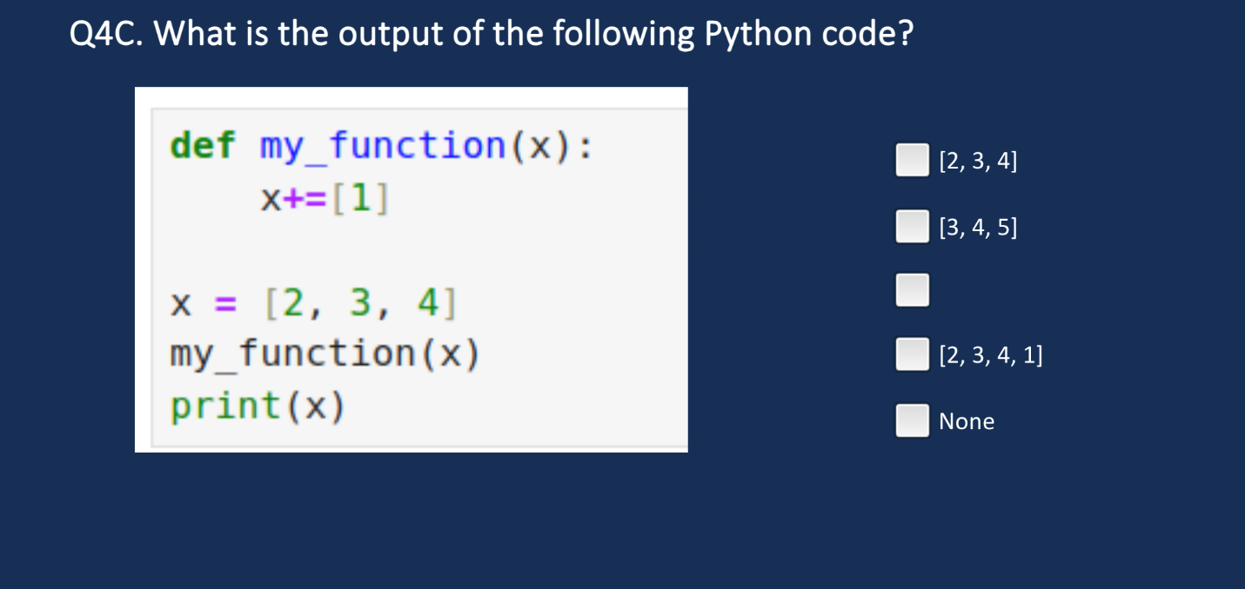

Font different than other questions

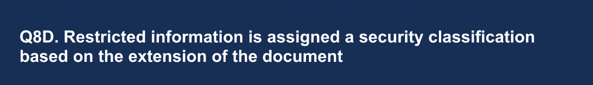

Change to “Your colleague has ....” and dot (.) after project.

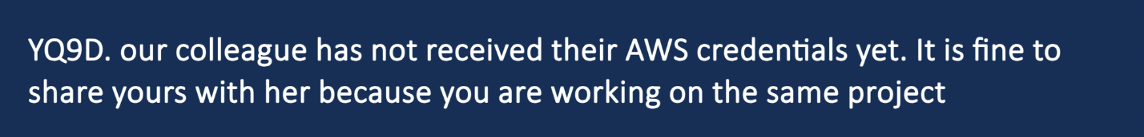

~~Change text to:~~

**~~Data Science Level 1 Certification Test~~**

**~~Part 2: 15 questions, 110 minutes~~**

~~Part 2 requires test takers to:~~

1. ~~Download one or more datasets.~~
2. ~~Create a code notebook – Python or R – using their own computer environment, for use in answering questions about the dataset(s).~~
3. ~~Upload their completed code notebook through the testing platform (after all questions are completed, test takers will be directed to a new page for uploading).~~

~~Formatting:~~

* ~~Align title with the rest of the text~~
* ~~Title color should be same as teal color used in Data Lab logo~~

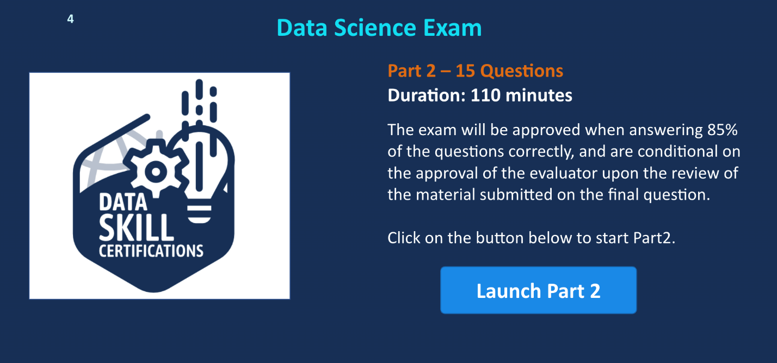

~~Change text to:~~

**~~Directions~~**

~~To complete the following 15 questions, you will need to download two datasets:~~

* ~~Movies – A dataset that includes information about movies, such as genre, budget, and rating.~~
* ~~Credits – A dataset that includes credits – actors, etc. -- for movies in the movie dataset.~~

~~Set up a code notebook – Python or R – to answer the questions. You will be required to upload your completed work upon completion of the test.~~

~~---~~

~~You may proceed to the questions only AFTER you have retrieved /saved the data and set up a code notebook.~~

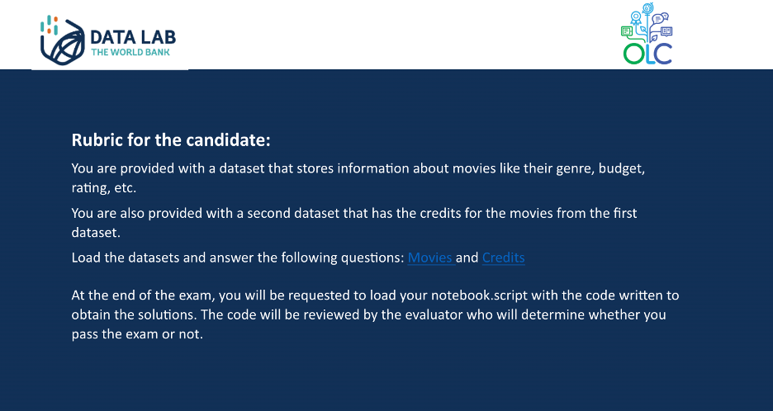

Change text to:

Course Title: Data Science Level I

Description: After you have completed Parts I and II of the certification test, please upload the code notebook you used to answer Part II questions. Notebooks must:

* Include question #’s.
* Clearly show how questions were answered using code.

The test taker will pass the test if they answer at least 85% of questions correctly and their uploaded notebook is approved by the certification team (please allow at least 5 business days for the notebook review). The test taker will receive an email with their final result.

Objectives: *remove*

References: to be uploaded.

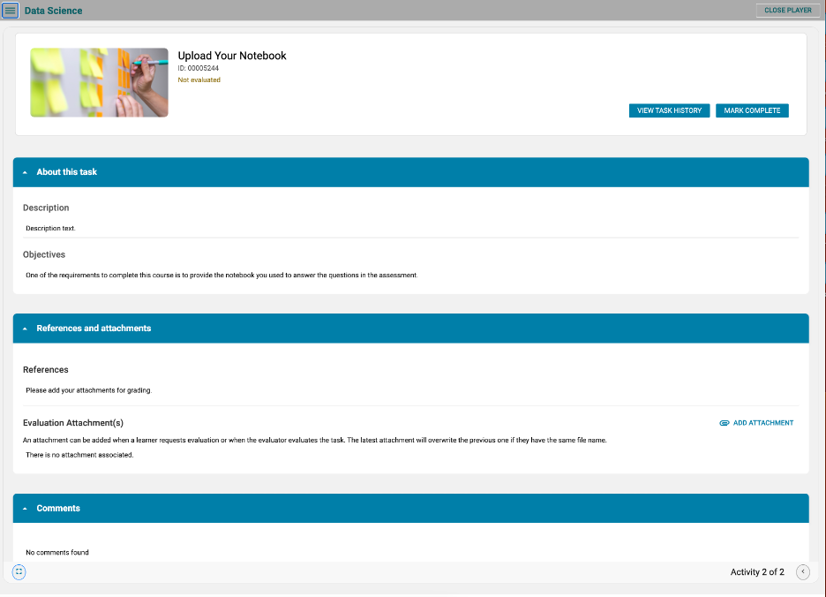

The beginning T is missing.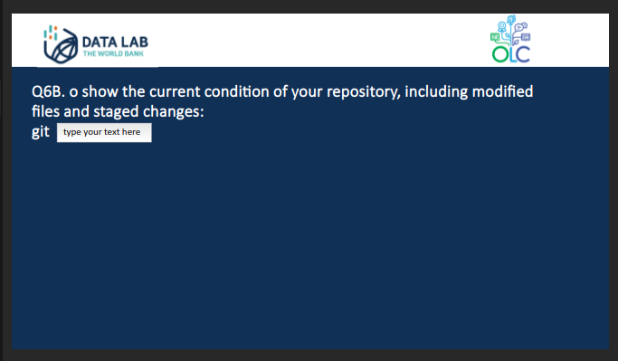

Question Q12C should ask for runtime and budget. However, I got asked by vote_average and popularity

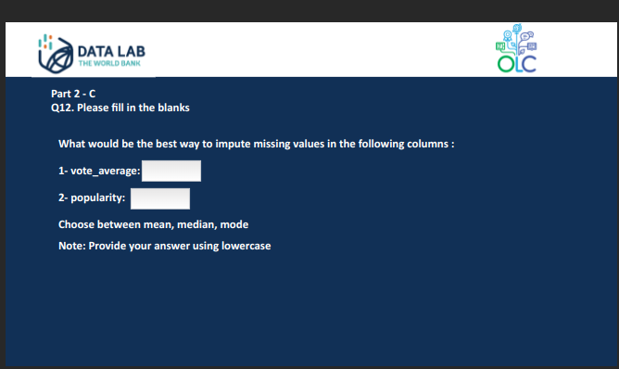

Part 2C from Q13 it jumped to Q17. The questions order should be followed because otherwise, the students will not arrive to the correct answer.

Typo in last line: Theoriginal. This was wrong on the main doc file (sorry)

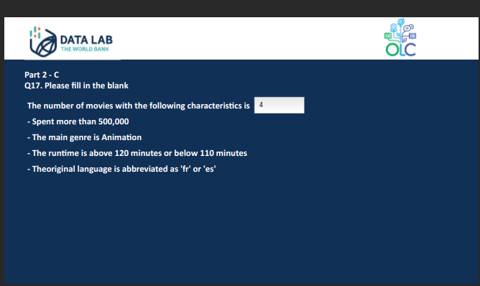

Q19 is missing

Not sure if this is an issue. In the original doc file, the answer order was differente. As long as the answer is ok, then, changing the order is fine.

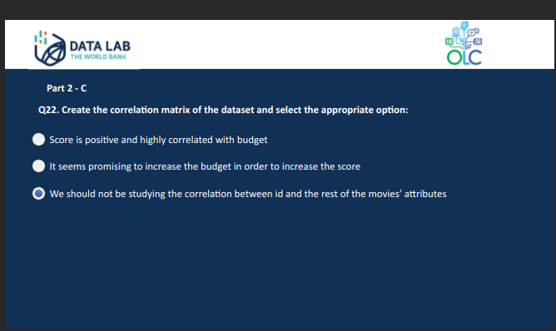

There seems to be some misalignment in the left block of text

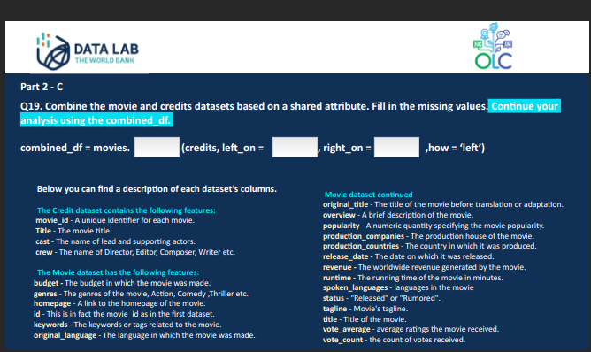

Alignment of the first two lines of text:

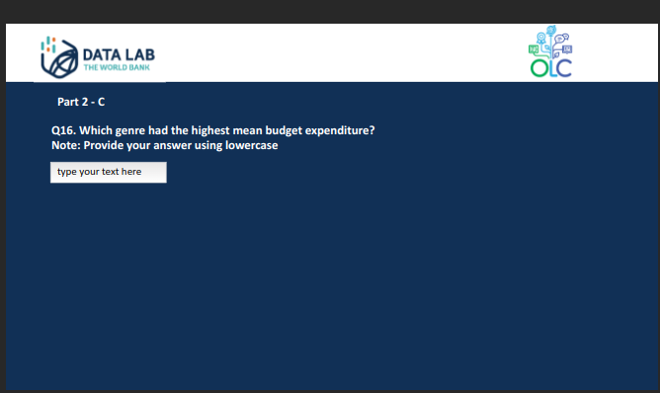

I took the test and uploaded a notebook. Is it ok that it says in progress?

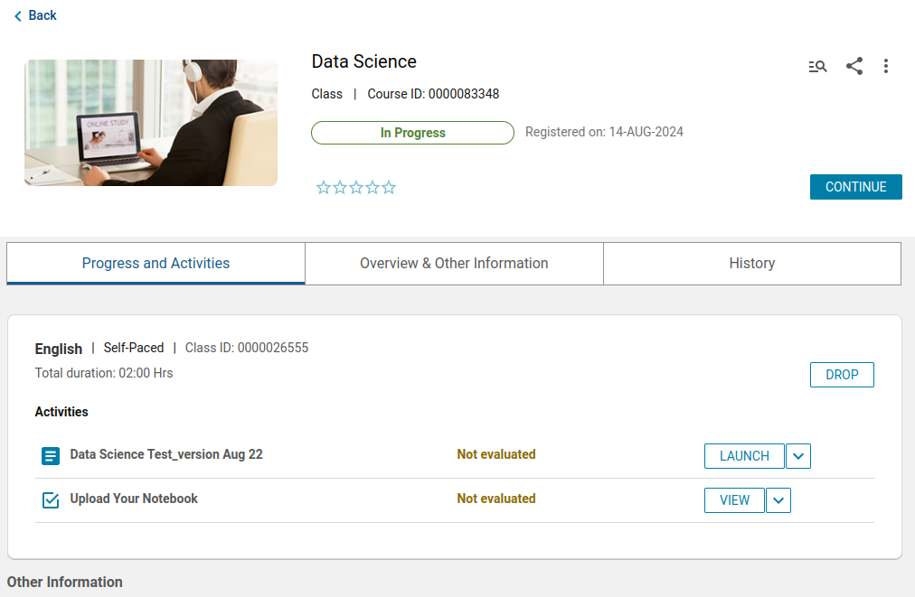

**FEEDBACK - SEP 4**

**NEW WORDING:**

**Data Science Level 1 Certification Test**

**Part 1: 9 questions**

**Duration: 10 minutes**

Part 1 comprises stand-alone multiple choice and fill in the blank questions that are randomly selected from a question bank.

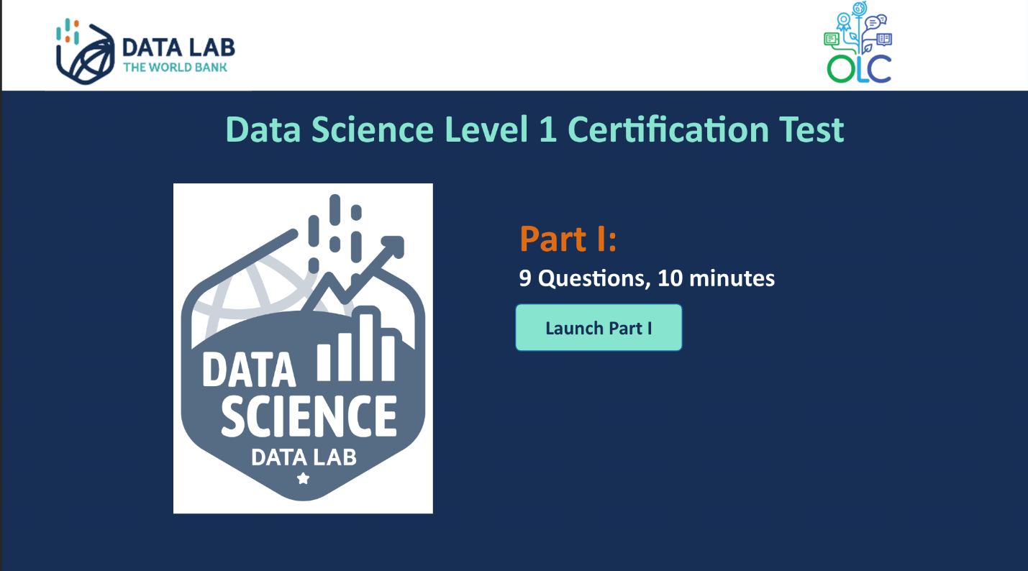

Done

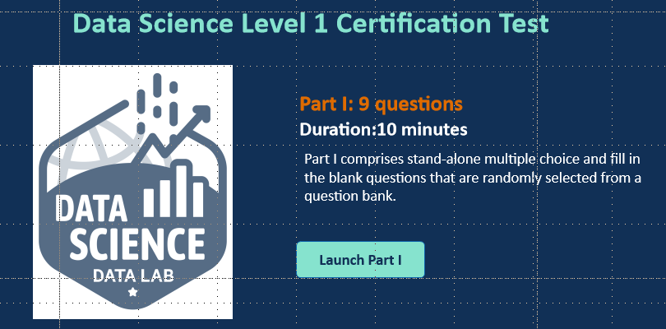

**WRONG ANSWERS LISTED**

**CORRECT ANSWERS:**

A) [True, True, False]   
B) True   
C) [False, False, True]   
D) [False, False, True, True]   
E) [False, False, True, False]   
F) [True, True]

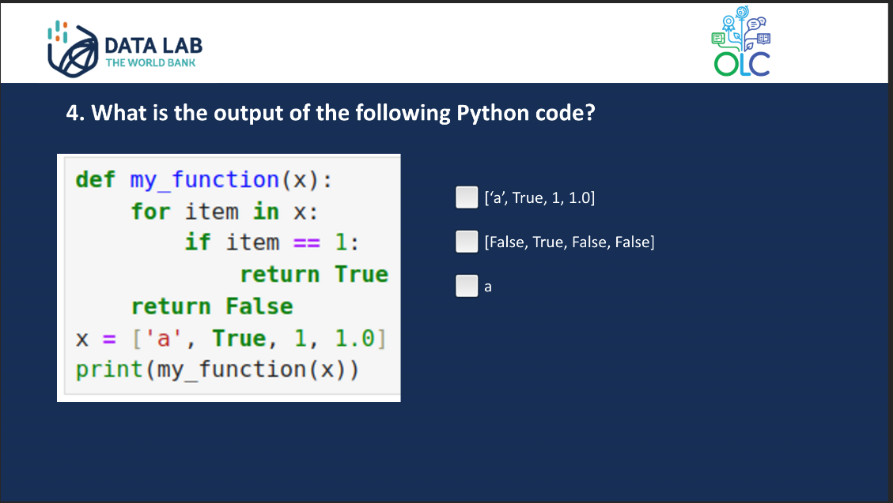

Done

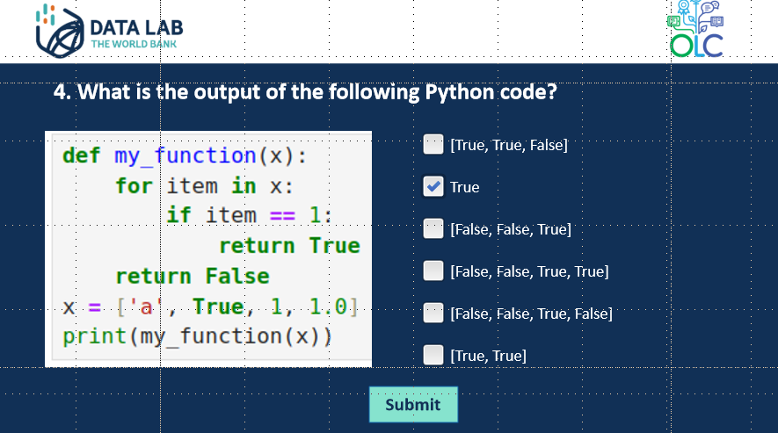

**WRONG ANSWERS LISTED**

**CORRECT ANSWERS:**

A) [1, 2, 3, 4]

B) crop, Price, Quantity

C) Price, Quantity

D) farmerid, Price, Quantity

E) farmerid, crop, Price, Quantity

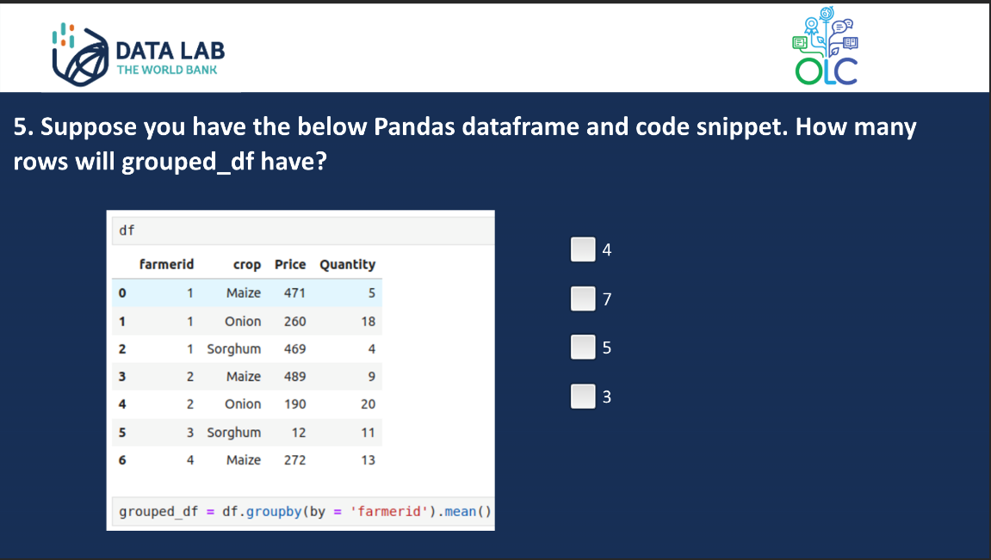

Done

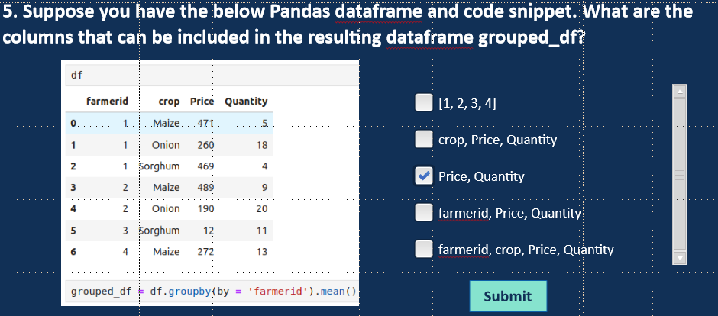

Clone is part of the answer. I had already fixed it in the word doc. It was my typo.

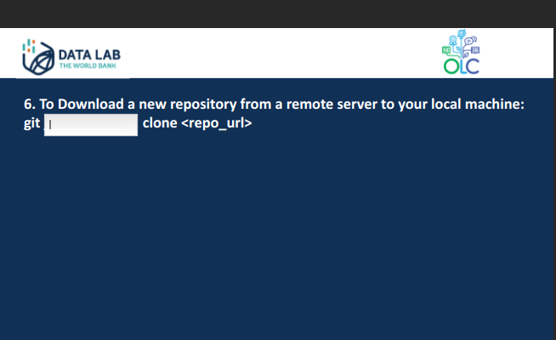

Done

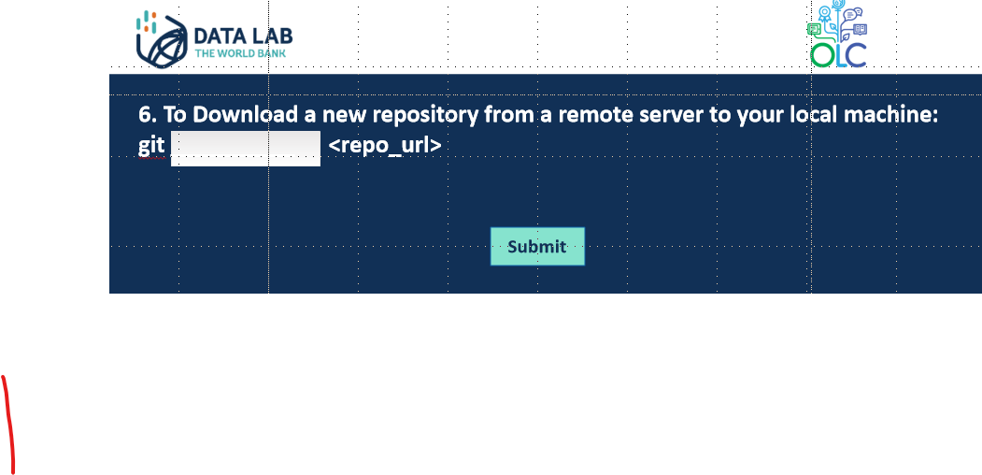

The image belongs to another question.

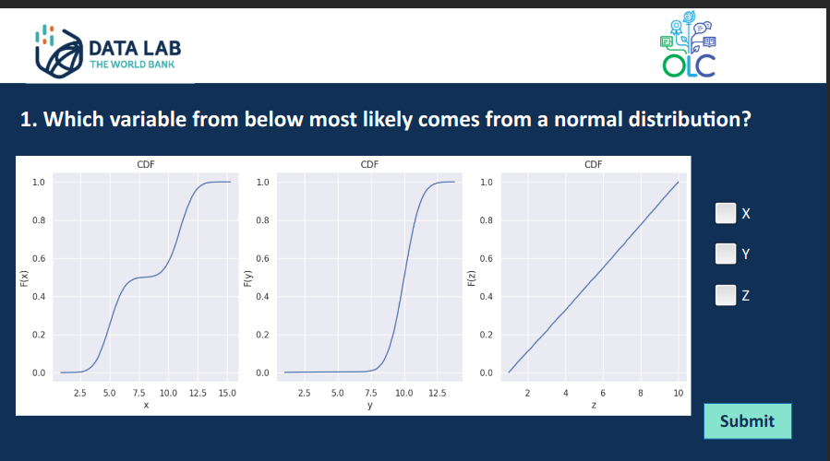

Done

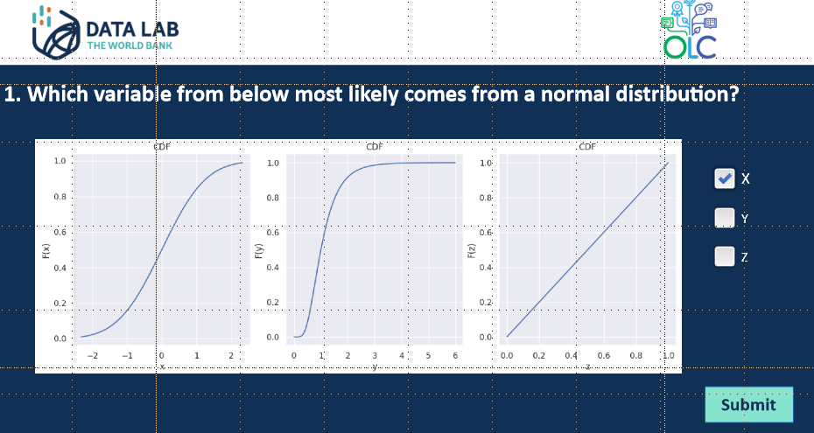

In Q17, Part II iteration 3, I wrote the answer and it kept telling me that I needed to fill in the blank. I was not able to take a screenshot

DONE – Fixed

The exit page has formatting issues

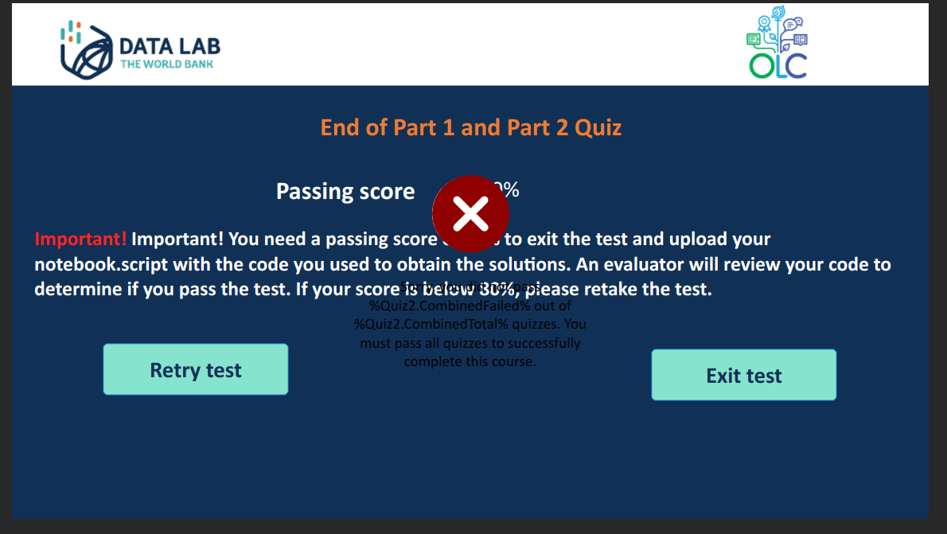

**FEEDBACK - SEP 5**

I get the error even though I filled in the blanks. Q15 iteration 4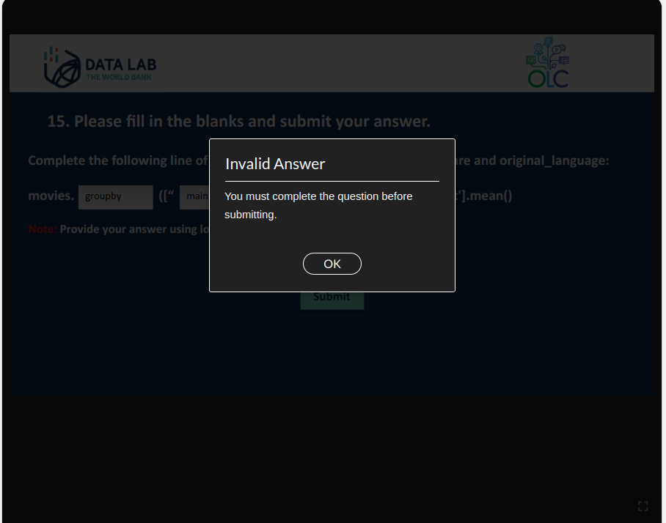

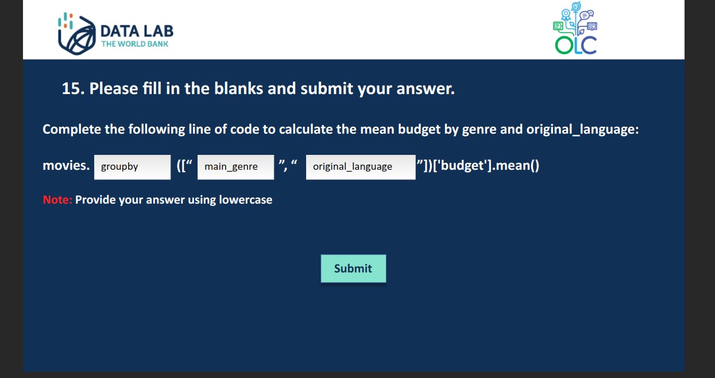

**FEEDBACK - SEP 11**

In the last slide, could it be notebook/script instead of notebook.script. The point is confusing as it seems to be the file extension.

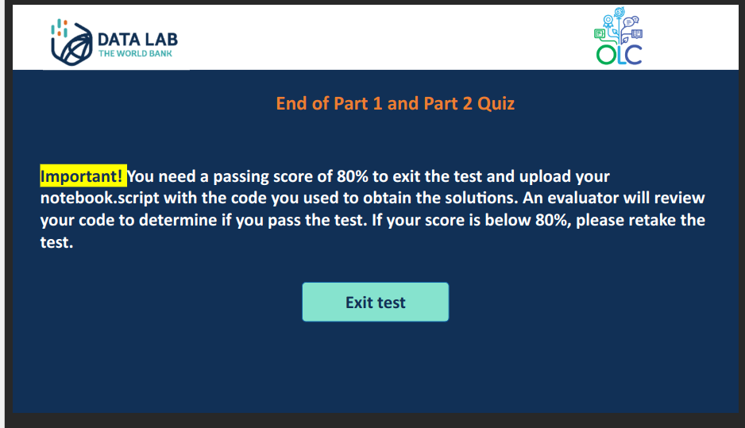

I got the same error as in September 5. It tells me that I need to complete the question but I had already done it.

